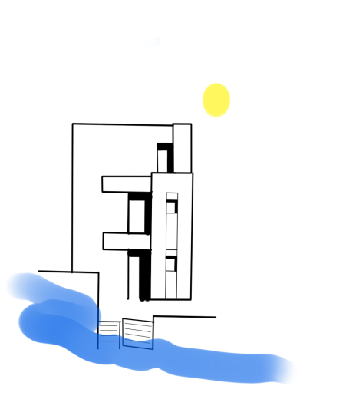BEACH NEST AVATON

## 

## Pocket wi-fi 26mbps.

## Outdoor furniture

## Patio or balcony private.

## Clothes rack

## Boiler

## Free parking on property, Parking on a private road • 2 spaces.

## Beach items,Beach towels, umbrella, mat

## Basic necessities

## Towels, sheets, soap and toilet paper, Shampoo

## Shower gel/body soap

## Extra pillows and blankets

## Long stays are allowed

## Stays of 28 nights or more are permitted

## Board games

## Indoor fireplace (wood).

## Hot water

## Private entrance

## Separate entrance from another street or to another building

## Coffee maker, French press, filter coffee maker, espresso machine.

## Air conditioner with two units without a vent.

## Kitchen, area where guests can cook

## First aid kit

## Hangers

## Mixer

## Cookware

## Pots and pans, oil, salt and pepper

## Children's cutlery

## Plates and cutlery

## Bowls, chopsticks, plates, mugs, etc.

## BBQ cookware

## Fuel and utensils used for grilling food

## Deckchairs

## Back yard private • fully fenced.

## Hair dryer

## Washing machine • at the accommodation.

## Wine glasses

## Fireplace protector

## Cleaning products

## Resort access, Beach access, Private, Beachfront.

## Fire extinguisher

## Iron

## TVHD • Classic Cable TV, DVD Player.

## Oven stainless steel • Bauknecht.

## Microwave

## Toaster

## Clothes storage area wardrobe, Chest of drawers.

## Barbecue grill private • Coal, Wood.

## Outdoor dining area

## Refrigerator with freezer (Whirlpool 200X60X60).

## Mini fridge (mini bar)